
It’s summertime and we hope that everyone is doing good at keeping cool!
In June, the City of Everman hosted a Town Hall Meet & Greet at our brand-new Civic Center. This was an excellent meeting that allowed us the opportunity to discuss many of the on-going and planned projects happening around our community. It also allowed us the opportunity to engage and receive feedback from citizens on what matters most to you. As we are preparing for the next budget year, this meeting was crucial in identifying appropriate focus areas for our budget. We are so thankful to all of you who came out to this event. We plan to continue this event every year as we truly see the value in community engagement.
The Everman Fire Department also hosted our annual Celebrate America Festival in June, which was a huge success! The fireworks were once again, amazing! Hats off to the Everman Fire Department for always putting on such a great event. We are excited for next year!
There are some great community events coming up that you are not going to want to miss. First, we hope that you can join us for the 09/11 Remembrance Walk on September 11th at 1:00pm. We will kick the event off at the Everman Memorial Park located at 400 N. Race St., followed by a walk/run event around Pittman Park.
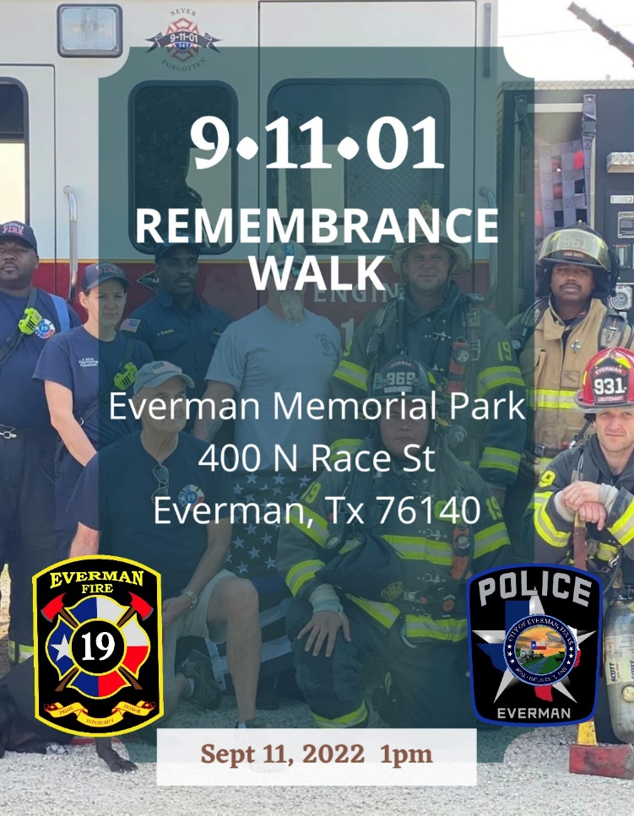

National Night Out is also coming up on Tuesday, October 4th at 6:00pm. National Night Out is about the community coming together to stand-up against crime. This is a truly fun event that we are so excited to host again. The Everman Police Department, along with other first responders and public works, will have various tools and equipment out for display and show. We will also have a variety of vendors on site as well. There will be all types of activities for the kids and we hope to see you and your family there!
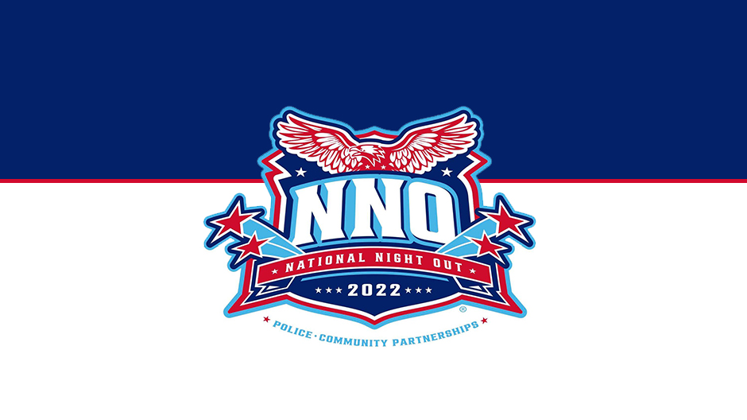
Lastly, On July 18th, after several years of service, Councilman Kelly Denison resigned his position as City Council Place 2 with approximately 21 months left in the term. The term for City Council Place 2 will expire in May of 2024. In accordance with the Everman City Charter, The Everman City Council will call for a Special Election this upcoming November to fill this vacancy for the remainder of the term. Anyone desiring more information, or with questions, should contact City Secretary Mindi Parks at (817) 293-0525 or by e-mail at mparks@evermantx.net.
Take care, stay cool, stay safe!
C. W. Spencer
City Manager
Fire Department
Its summer time in Texas and Whew it’s a hot one out there! So hot, the firefighters had to trade up with oven mitts for gloves to get the heat protection needed!


Of course, were only kidding about the oven mitt, but were serious about the heat! From all of #YourEvermanFirefighters, we ask and urge everyone to take care of yourselves and your neighbors during this stressful hot summer period. The record heat has taken its toll on everyone, and there are still many weeks ahead. Know the signs and symptoms of heat stroke and exhaustion, stay cool, and stay hydrated with water! Prepare your mind and body for the conditions of tomorrow.

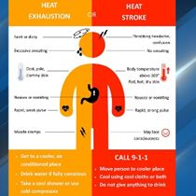
Despite the record setting head #YourEvermanFirefighters have been hard at work and not letting the heat slow them down! Multiple structure and grass fires have sparked over the past few months due to the hot and dry conditions. The low dew point, high winds, and lack of rain have fueled one of the worst grass fire seasons we’ve seen in over 10 years. Please remember to do your part to reduce any risk of sparking a grass fire.

Reminder that all of Tarrant County is under a very strict burn ban. We have had many questions and some confusion regarding what the burn ban means for Everman citizens. By ordinance, open burning is NOT allowed within the city limits of Everman. What does that mean exactly you ask? Open burning means burning materials in an open area with no grate or cover in place and not contained within a barrel or pit. It also restricts what materials you can burn, when you can burn, and where you can burn. For more information, please visit our website or call and speak with the fire marshal’s office within the fire department.

The new Pierce Truck 19 in its final stages of production and anticipating delivery sometime late August or early September! It boasts a 107ft ladder, 500-gallon water tank, full array of fire and rescue tools as well as advanced life support medical equipment. Keep an eye on the Everman Emergency Services Facebook page for new updates and when we plan to have the traditional push in ceremony that will be open to the public!

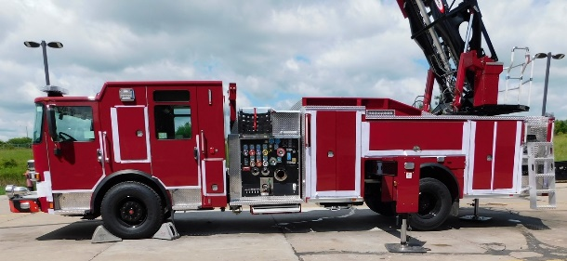
We would like to thank everyone that made it out to the 2022 Celebrate America Festival. Despite the near record heat, the community came out in full force to enjoy all the festival had to offer. We had such a great turn out and response that we have already started working to organize next year’s event. We know such a large event wouldn’t be possible without our generous donors and the awesome vendors that braved the heat and made it out. I very special thank you to all those listed below. We hope you return again next year as well.

2022 Official Sponsors
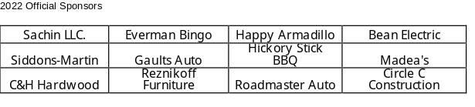

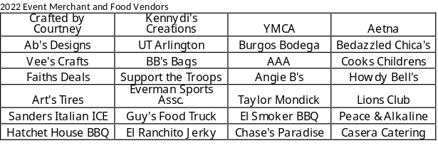
Remember you can tag us or use the hashtag #YourEvermanFirefighters on social media

L. Whatley
Chief of Department/FMO
Economic Development News
The Tarrant County Small Business Workforce Recovery Grant Program portal opened at noon yesterday. Since then, the County has received numerous calls from applicants who were having trouble obtaining a SAM number in a timely manner. In an effort to ensure that all eligible applicants have an opportunity to submit their application, this morning the County lifted the requirement that the SAM number be provided at time of application, due to the backlog with the federal Unique Entity Identifier SAM number generation process causing delays. The applicant will still need to apply for and obtain this number before receiving a potential grant award. In order to be considered for funding, the business must have an otherwise complete accurate application. Businesses without a SAM number may submit an application by marking “no” at the question related to the SAM number. Thank you.
To apply please visit www.tarrantcounty.com/recovery. Funding is limited and applications will be processed in the order they are received.
The application will be solely online and all documentation must be included for the application to be considered eligible for review. For assistance with documentation scanning and upload, applicants may contact the Commissioner’s Office in their precinct.

The EDC is working on a few new projects and we hope to provide news on those soon! Thank you for supporting Everman Businesses! Remember that your hard-earned money should be spent in YOUR community so the tax dollars are reinvested into YOUR community. SHOP EVERMAN FIRST!

EVERMAN UTILITY BILLING DEPT
We have updated our website for easier access to all residents. We have added water service documents, garage sale permit application, rental registration forms, and pavilion and Civic center rental applications. Our water customer service policy is also available online. For more information, please visit http://www.evermantx.us/wp-content/uploads/2021/09/2.1-Water-Customer-Service.pdf
We recently switched over our online water bill payment system. With this change residents can now log in to their account and have access to print their water bill, consumption report and view transaction history and set up automatic payments. For more information, please visit http://www.evermantx.us/payments/water-utility/
Garbage Collection

Waste Connections provides garbage collection. In order to expedite garbage collection, the following information is provided.
1. City-wide pick-up days are Tuesdays and Fridays; Fridays are also recycling days. Waste Connections observes the holidays of Thanksgiving and Christmas and New Year’s. If your collection day falls on one of these holidays, call (817) 222-2221 for collection day.
2. Garbage must be out front at curbside by 7:00am on your collection day.
3. Discounts are provided to Senior Citizens. To apply for a discount contact City Hall at
(817) 293-0525.
4. No hazardous waste, tires, batteries, liquids or inflammables can be left for collection.
5. We encourage you to contact Waste Connections directly if you are experiencing a problem with your garbage collection at (817) 222-2221.

EVERMAN MUNICIPAL COURT

The Everman Municipal Court as a Court of Record, serves its citizens and guests within the community in a courteous, efficient, and professional manner. The court and its officers process cases in a fair and impartial manner.
Our mission is to provide effective and impartial administration of justice. We are dedicated and committed to promoting the highest standards in customer service, upholding the integrity of the court, and building public trust and confidence.
The Everman Municipal Court adjudicates Class C misdemeanor offenses and
city ordinance violations punishable by fine only. The Court Office is located in the
Everman City Hall and is staffed with a Court Clerk who can assist you daily. The
Court Clerk is not a licensed attorney and CANNOT provide you with legal advice!
The Municipal Court accepts, Credit cards, checks and money orders as a form of payment.
You have ten (10) calendar days from the date of your citation to either pay the
citation, make a payment plan or set your citation for court. You will need to make an
appearance in person, by mail or by attorney representation by your appearance date.
These dockets will be set for a one-hour session at various times every second Friday of the month between the hours of 1:00 p.m. to 4:00 p.m.
please visit http://www.evermantx.us/municipal-court/
Code Enforcement
Ordinances can be found on the City of Everman website
# 753- This Ordinance requires that all tree limbs/branches maintain a 15ft clearance above roadway, immediately adjacent to the curb (can the picture be attached to the article?).

#26- This Ordinance requires that water accounts are required to change when premise changes occupancy and/or ownership. Should the owner or occupant pass away, the water account shall be updated.

#679 Zoning Ordinance - Parking is required to be on a wholly paved surface comprised of concrete or asphalt.

#513 Inoperable Vehicle - This Ordinance requires that any vehicle wrecked, dismantled partially dismantled and with expired registration is deemed inoperable/junk and is required to be repaired or removed from public view.

#564- This Ordinance requires that the parking of large and/or commercial vehicles, RVs to be on a wholly paved surface comprised of asphalt or concrete, in an enclosed structure, out of 1o ft. City utility easement.
(Ord #742 RVs are not permitted to be lived in more than 14 days, cannot be connected to water/sewer, can be connected to electric only to charge battery).

#554 Nuisance Ordinance - Accumulation of refuse is not permitted on private property in public view. Refuse is defined as any accumulation of worn out, used, broken, or rejected materials and includes garbage, litter, rubbish, yard waste, and other decayable or non-decayable waste. It includes but is not limited to old barrels, old tires, tree and brush and grass trimmings and used household items and appliances.

Donna Wilkerson,
Code Enforcement

Everman Police Department
CRIME WATCH MEETINGS ARE BACK! Moving forward from the COVID restrictions and now that our new Civic Center is open, we have resumed the monthly Crime Watch meetings. These meetings are designed to inform, educate and entertain as we discuss current police activity in our area as well as provide education on topics to help keep you safer. We will be presenting programs on alarms systems, security lighting, locking devices and cyber security just to name a few. We will also be introducing you to officers that patrol your neighborhoods and discussing their involvement in specialty units such our drone unit, K-9-unit, School Resource Division and Criminal Investigation Division to name a few. These meetings are conducted by retired Police Chief Randy Sanders, who provides a little insight into the operations of your police department and law enforcement in general. Crime Watch meetings also provide an opportunity for our neighbors to ask questions or share information about potential criminal activity (or just areas of concern) in the neighborhoods. We are all partners in crime detection and prevention. These meetings are an excellent opportunity to solidify that relationship to help make Everman a safer, better place to live. If you’ve never attended, please come join us at 7pm on the second Thursday of each month at the beautiful new Civic Center at 213 N. Race Street. If you have attended, please come again … and bring friends and neighbors! We look forward to seeing a lot of you there soon.
It’s back to school time again which means SCHOOL ZONES will be active and vigorously enforced. We realize drivers develop habits which change slowly however, even a slight bit of driver inattention is dangerous to the precious children walking to and from our schools. Please be aware of school zones and the children moving about. We are watching out for them … and we are watching out for inattentive drivers who could cause them harm.
We would like to remind everyone (not that we really need to) that it’s HOT. It is extremely hot this Summer and it’s not over yet. Please hydrate yourselves accordingly. Don’t wait until you are out in the sun to start. Stay hydrated. Drink plenty of water well before beginning outdoor activity. Watch for signs of overheating. If you feel lightheaded, dizzy, nauseous, confused, develop muscle cramps or develop goosebumps in the heat, move to a cooler area immediately AND call 9-1-1 for medical assistance. Provide cool shelter and plenty of water for outdoor pets and please check on elderly neighbors, or those with mobility issues, often. Let’s take care of each other.
From all of us at the Everman Police Department, we hope you have a safe and enjoyable Summer and look forward to a cooler Fall!
Everman Library News
Good day from The Everman Public Library, we hope you have enjoyed your summer and have made great memories with your family! We hope you have taken some time to read a good book and have, gotten some much needed rest. If you haven’t visited us yet, please stop by soon.
Our friendly staff is ready to help you. We’ve added many new books, DVD’s and new magazine subscriptions to our collection.

Our library staff has been busy this summer, our event coordinator Iliza Barrios has done such a
fabulous job! This year’s summer reading theme was “Oceans of Possibilities” such a fun theme.
We are the uttermost thankful for “Friends of the Library!” Extremely thankful for Ms. Betty Anderson, for helping us make this program available to our community! We appreciate all the time and effort invested in the Summer Reading Program! The children were delighted to each receive a fun toy each week and a book on the last day. Also, a big Thank You to all our readers, Officer Rhea, Officer Morado, Ms. Nateros, and Ms. Bomb. The children and families really enjoyed, listening to story time and learning about their careers.
We have continued with story time at the library for the month of July on Saturday’s. We are thankful and have enjoyed having our readers Mrs. Mackey and Officer Dabbs. Each child who has attended has received a favor bag from us, we are glad you have joined us and we hope you have enjoyed coming to the Everman Public Library.

We hope you are doing the best to stay cool and hydrated and we want to wish you a
safe return to school and work. We hope to see you all very soon at the Everman Public Library.

Rosalinda Leon, Librarian

The Charter Commission believes that anyone running for or actively sitting as the Mayor or City Council Member should be a qualified voter, be a resident of the City for at least one year prior to election (and while serving as Mayor or Council Member if elected), should have no felony convictions, and should not be\ncially delinquent to the City (i.e., property taxes {if property owned by candidate or spouse}, City Utility payments, any other City fees). The Charter Commission believes that the sitting Mayor and Council Members or candidates for Mayor or Council Member should have these qualifications to govern the citizens they serve fairly, efficiently, and effectively.

If any member of the City Council fails to maintain the aforementioned or foregoing qualifications, or fails to attend three (3) consecutive regular meetings of the City Council (this includes the work session regularly scheduled in week one of each month and the regular Council meeting held in week two of each nth), during each elected year (unless the City Council deems the absences as “excused”), or shall be convicted of a felony or offense involving moral turpitude, the City Council shall declare a vacancy in the office of that member of the City Council at its next regular meeting and shall fill the vacancy as set forth in this Charter.

The Charter Commission believes that anyone running for or actively sitting as the Mayor or City Council Member should be a qualified voter, be a resident of the City for at least one year prior to election (and while serving as Mayor or Council Member if elected), should have no felony convictions, and should not be financially delinquent to the City (i.e., property taxes {if property owned by candidate or spouse}, City Utility payments, any other City fees). The Charter Commission believes that the sitting Mayor and Council Members or candidates for Mayor or Council Member should have these qualifications to govern the citizens they serve fairly, efficiently, and effectively.

If any member of the City Council fails to maintain the aforementioned or foregoing qualifications, or fails to attend three (3) consecutive regular meetings of the City Council (this includes the work session regularly scheduled in week one of each month and the regular Council meeting held in week two of each month), during each elected year (unless the City Council deems the absences as “excused”), or shall be convicted of a felony or offense involving moral turpitude, the City Council shall declare a vacancy in the office of that member of the City Council at its next regular meeting and shall fill the vacancy as set forth in this Charter.

